**- MODULE 2 : BUILD YOUR PORTFOLIO -**

In this part of the course, you’ll review two possible tracks to complete your case study. You can use a dataset from one of the business cases provided or search for a public dataset to develop a business case for an area of personal interest. In addition, you'll be introduced to several platforms for hosting your completed case study.

### 

### **Learning Objectives**

* Apply the practices and procedures associated with the data analysis process to a given set of data.
* Discuss the expectations involved in completing a data analysis case study.
* Move their portfolio to Kaggle, post and make it public
* Add R Code to a Kaggle Notebooks
* Recall the different types of Kaggle Notebooks

GET STARTED

[INTRODUCTION TO BUILDING YOUR PORTFOLIO](https://www.coursera.org/learn/google-data-analytics-capstone/supplement/NNGNj/introduction-to-building-your-portfolio)

In this part of the course, you will prepare a case study that you can include in your online portfolio. All of the resources provided will help you to succeed in this goal (referred to as the Google Data Analytics Capstone).

**There is an old saying that you learn by doing.** You have already learned about the importance of each phase in the data analysis process when working with a dataset. You will soon learn about the importance of having an online portfolio. The Google Data Analytics Capstone will enable you to actually put the two together—a dataset you took through the data analysis process for your portfolio.

By completing your capstone project, you will practice:

* Going through the Ask, Prepare, Process, Analyze, and Share phases of the data analysis process
* Stating a business task clearly
* Importing data from a real dataset
* Documenting any data cleaning that you perform on the dataset
* Analyzing the data
* Creating data visualizations from your analysis
* Summarizing key findings from your analysis
* Documenting your conclusions and recommendations
* Creating and publishing your case study

Your case study will demonstrate these fundamental skills to prospective employers and showcase what you have learned from the Google Data Analytics Certificate. It will represent your knowledge and capabilities in your portfolio.

[GET STARTED WITH YOUR CASE STUDY](https://www.coursera.org/learn/google-data-analytics-capstone/lecture/AOqWB/get-started-with-your-case-study)

Hello! Great to see you again. Now that we've checked out some example case studies and portfolios, it's time to start creating your own. Coming up, you'll do an activity that'll help you get started. But before that, I wanted to tell you a little bit about the different approaches you can use to start your project. There's two possible tracks you can use to frame out your case study and help you get started. In Track 1, you'll be able to choose a business question similar to the kind that interviewers might ask. There are several different options for you to choose from, with specific business tasks and different datasets for you to use. In Track 2, you'll be asked to find a public dataset to explore something you're personally interested in. This could be anything. From analyzing a video game you like, to a study on a wildlife population you care about. This is the more flexible option, and you'll have more freedom to build something that's really personal to you. Depending on what you want to do with your case study, you might choose one over the other. For example, if you want to create a case study that you can use to demonstrate your job skills for future interviews, then Track 1 might be more useful for you but if you have something you're personally interested in that you'd like to explore more, Track 2 can help you build a flexible portfolio piece. Or if you're interested in Track 1 and 2, you can do both. Once you've decided on the track you're most interested in, you'll use the case study outline to help you start your project. The outline follows the phases of the data analysis lifecycle that we've been using throughout this program. You'll complete each phase from asking the right questions to preparing, processing, and analyzing your data, until you finally build your presentation and share it in your portfolio. Each phase will have key questions and activities to help guide you through the process. If you ever need to review something, you can always go back to any part of the program to help you. As a quick reminder, the data you'll be working with for this project will be public and open-source. This data is great for demonstrating your skills as a data analyst but it's essential to avoid plagiarism by citing your sources. Public, open-source data can be easily searched, and we don't want to pass it off as our own work. Plagiarism can have serious negative consequences, legally and personally. The beauty of our work as data analysts is that we can share and collaborate with each other. So let's remember to give credit to our sources. I hope you're excited about starting your case study. I'm really excited to see what you'll put together. After this, you'll be able to start working on the outline. Then we've got some other activities that'll help guide you. After that, we'll talk about sharing your portfolio. Good luck.

[CHOOSE YOUR CASE STUDY TRACK](https://www.coursera.org/learn/google-data-analytics-capstone/supplement/NTV8r/choose-your-case-study-track)

A **case study** is a common way for employers to assess your skills and observe how you would approach a data-related project. For example, you might be asked to clean and analyze a dataset, create a proposal around how to measure the success of a project, or figure out and define success metrics for a given project.

In this course, you will practice working with a case study. You can fulfill the case study requirement through one of two tracks.

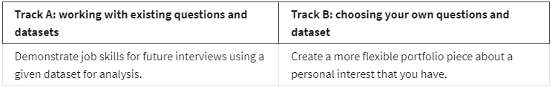

## [**TRACK A**](https://www.coursera.org/learn/google-data-analytics-capstone/supplement/bY66y/track-1-details)

If you select Track A, you can choose from these two options to complete your case study requirement:

* **Case study: Cyclistic bike-share analysis**

This is an opportunity to analyze historical bicycle trip data in order to identify trends. Understanding how casual riders behave differently from riders with paid memberships is important. This analysis will help executives to make decisions about marketing programs and strategies to convert casual riders to riders with annual memberships. Refer to [Case Study 1: How Does a Bike-Share Navigate Speedy Success?](https://www.coursera.org/learn/google-data-analytics-capstone/supplement/7PGIT/case-study-1-how-does-a-bike-share-navigate-speedy-success) for more details about this case study

* **Case study: Bellabeat product analysis**

This is an opportunity to analyze publicly available fitness tracker data in order to gain insights into how consumers are using these products. Identifying any trends in this data will be key. This will help Bellabeat, a high-tech manufacturer of health-focused products for women, determine marketing strategy in the future. Refer to [Case Study 2: How can a wellness company play it smart?](https://www.coursera.org/learn/google-data-analytics-capstone/supplement/ZsmDD/case-study-2-how-do-media-companies-find-the-next-binge-worthy-show) for more details about this case study.

## [**TRACK B**](https://www.coursera.org/learn/google-data-analytics-capstone/supplement/zbwbs/track-2-details)

If you select Track B, you must search for a public dataset that focuses on an area of interest to you. Are you interested in housing the homeless? Are you interested in conserving open spaces for public use? Are you interested in figuring out if Bitcoin is a good investment? Track B gives you freedom to investigate anything that you like, but it does assume that you will be self-directed to develop your own case study from scratch. You will need to come up with all the requirements for the analysis.

Refer to these resources for additional information before selecting this more advanced track:

* Download [Case Study 3: Follow Your Own Case Study Path](https://www.coursera.org/learn/google-data-analytics-capstone/supplement/vcS93/case-3-packet-choose-your-own-adventure): These instructions describe what is involved to select public datasets and the process to create your own case study.
* [Resources to explore other case studies](https://www.coursera.org/learn/google-data-analytics-capstone/supplement/ZQGDM/resources-to-explore-other-case-studies): This reading describes how to browse other case studies for inspiration using Medium, GitHub, Tableau, and Kaggle.
* [Exploring public datasets](https://www.coursera.org/learn/data-preparation/supplement/8yrhM/exploring-public-datasets): This reading provides a list of public dataset sources that you can explore to create your case study. Did you feel excited when you were asked if you were interested in figuring out if Bitcoin is a good investment? This reading includes a link to Bitcoin’s historical data on Kaggle.

[CAPSTONE ROADMAP](https://www.coursera.org/learn/google-data-analytics-capstone/ungradedWidget/8j3Hf/capstone-roadmap)

**1-Ask:**

**Guiding questions**

What topic are you exploring?

What is the problem you are trying to solve?

What metrics will you use to measure your data to achieve your objective? Who are the stakeholders?

Who is your audience for this analysis and how does this affect your analysis process and presentation?

How will this data help your stakeholders make decisions?

**Key tasks**

It’s important to understand the problem and any questions about your case study early on so that you’re focused on your stakeholders’ needs.

Choose a case study

Identify the problem

Determine key stakeholders

Explore the data and establish metrics

**2-Prepare:**

**Guiding questions**

Where is your data located?

How is the data organized?

Are there issues with bias or credibility in this data? Does your data ROCCC?

How are you addressing licensing, privacy, security, and accessibility?

How did you verify the data’s integrity?

How does it help you answer your question?

Are there any problems with the data?

**Key tasks**

The Prepare phase ensures that you have all of the data you need for your analysis and that you have credible, useful data.

Collect data and store it appropriately

Identify how it’s organized

**3-Process:**

**Guiding questions**

What tools are you choosing and why?

Have you ensured your data’s integrity?

What steps have you taken to ensure that your data is clean?

How can you verify that your data is clean and ready to analyze?

Have you documented your cleaning process so you can review and share those results?

**Key tasks**

Now that you know your data is credible and relevant to your problem, you’ll need to clean it so that your analysis will be error-free.

Check the data for errors

Transform the data into the right type

Document the cleaning process

Choose your tools

Sort and filter the data

Determine the credibility of the data

**4-Analyze:**

**Guiding questions**

How should you organize your data to perform analysis on it?

Has your data been properly formatted?

What surprises did you discover in the data?

What trends or relationships have you found in the data?

How do these insights answer your question or solve the problem?

**Key tasks**

Now you’ll really put your data to work to uncover new insights and discover potential solutions to your problem!

Aggregate your data so it’s useful and accessible

Organize and format your data

Perform calculations

Identify trends and relationships

**5-Share:**

**Guiding questions**

What story does your data tell?

How do your findings relate to your original question?

Who is your audience? What is the best way to communicate with them?

Can data visualization help you share your findings?

Is your presentation accessible to your audience?

**Key tasks**

During the share phase, you’ll tell a story using data and communicate your findings.

Determine the best way to share your findings

Create effective data visualizations

Present your findings

Ensure your work is accessible to your audience

**6-Act:**

**Guiding questions**

What is your final conclusion based on your analysis?

How can you apply your insights?

Are there any next steps you or your stakeholders can take based on your findings?

Is there additional data you could use to expand on your findings?

How can you feature your case study in your portfolio?

**Key tasks**

After this, your case study will be complete. But you can use these steps again to help guide you through your analysis process.

Share next steps with your stakeholders

Determine if more data could give you new insights

Upload to your portfolio

**CASE STUDY TRACK A** **:** WORK WITH EXISTING QUESTIONS AND DATASETS

[TRACK A DETAILS](https://www.coursera.org/learn/google-data-analytics-capstone/supplement/bY66y/track-a-details)

## **On the job**

The first track involves a case study similar to what you might be asked for in a job interview. You will be given a business task, dataset, and list of specific deliverables that you must present to stakeholders. The first track will help you to create a case study that you could include in your portfolio to demonstrate job skills for future interviews. You can choose from between two cases. Once you decide which case study packet to use, you will read the details, complete the analysis, and create your finished case study.

If this track interests you, explore the case study options and decide which one you want to perform. The case study packets available for download have everything that you need to complete your case study. Then, you will be ready to upload and share your case study with potential employers.

[CASE STUDY 1: HOW DOES A BIKE-SHARE NAVIGATE SPEEDY SUCCESS?](https://www.coursera.org/learn/google-data-analytics-capstone/supplement/7PGIT/case-study-1-how-does-a-bike-share-navigate-speedy-success)

In this case study, you will perform data analysis for a fictional bike-share company in order to help them attract more riders. Along the way, you’ll perform typical tasks of a junior data analyst while following the steps of the data analysis process: **Ask**, **Prepare**, **Process**, **Analyze**, **Share**, and **Act**. By the time you’re done, you’ll have a portfolio-ready case study to help you demonstrate your knowledge and skills to potential employers!

Download the packet and reference the details of this case study anytime:

[How-does-a-bike-shared-navigate-speedy-success](https://d3c33hcgiwev3.cloudfront.net/1XKhm37HS9iPXHfAIEBaRQ_ec9ad22caf394fec9608b08e556eb1f1_Case-Study-1_How-does-a-bike-shared-navigate-speedy-success_.pdf?Expires=1722556800&Signature=XhudqRJTtv2IdTd9vwYZr~fRGPfwKe5CF4v6qWdaOi8xgY34GiGfQqurAtajBvC~1AJt-lqTqBAsYwhAsALMXEEUXeRvzNylnUTCHG6ELOUr2LR35OOtgKqoRJTtrlzEzl-O-1mzRR0MCGjmp3r8QQ~Y8pkWT1m5gFOxo2YIJvc_&Key-Pair-Id=APKAJLTNE6QMUY6HBC5A)

[CASE STUDY 2: HOW CAN A WELLNESS COMPANY PLAY IT SMART?](https://www.coursera.org/learn/google-data-analytics-capstone/supplement/ZsmDD/case-study-2-how-can-a-wellness-company-play-it-smart)

In this case study, you will perform data analysis for Bellabeat, a high-tech manufacturer of health-focused products for women. You will analyze smart device data to gain insight into how consumers are using their smart devices. Your analysis will help guide future marketing strategies for your team. Along the way, you will perform numerous real-world tasks of a junior data analyst by following the steps of the data analysis process: **Ask**, **Prepare**, **Process**, **Analyze**, **Share**, and **Act**. By the time you are done, you will have a portfolio-ready case study to help you demonstrate your knowledge and skills to potential employers!

Interested? Download the case study packet:

[How-can-a-wellness-technology-company-play-it-smart](https://d3c33hcgiwev3.cloudfront.net/OLtArwsxSlar_y35df7xmQ_634dd308c7a04d24bdfdb9367f24d5f1_Case-Study-2_-How-can-a-wellness-technology-company-play-it-smart.pdf?Expires=1722556800&Signature=jy4cxTNMSbK4UWWczJqcp-uXKpgSim37I2KZLCXOafPCkivLML4A6h0wVqj9HPTRRrykAKhJtG2FPQkDKvAgG4ZxD-CKAivveDC7kT4syk0xq9ehSI-06bgsj2zRtrsVdg5W-sAlHU4czSsCQuf7fV~WcG9buL8YSQn9w7oc-ew_&Key-Pair-Id=APKAJLTNE6QMUY6HBC5A)

[CASE STUDY 1: HOW DOES A BIKE-SHARE NAVIGATE SPEEDY SUCCESS?](https://www.coursera.org/learn/google-data-analytics-capstone/discussionPrompt/3f0B9/case-study-1-how-does-a-bike-share-navigate-speedy-success)

[CASE STUDY 2: HOW CAN A WELLNESS COMPANY PLAY IT SMART?](https://www.coursera.org/learn/google-data-analytics-capstone/discussionPrompt/BQyYm/case-study-2-how-can-a-wellness-company-play-it-smart)

**CASE STUDY TRACK B :** CHOOSE YOUR OWN QUESTIONS AND DATASETS

[TRACK B DETAILS](https://www.coursera.org/learn/google-data-analytics-capstone/supplement/zbwbs/track-b-details)

[CASE STUDY 3: FOLLOW YOUR OWN CASE STUDY PATH](https://www.coursera.org/learn/google-data-analytics-capstone/supplement/vcS93/case-study-3-follow-your-own-case-study-path)

[RESOURCES TO EXPLORE OTHER CASE STUDIES](https://www.coursera.org/learn/google-data-analytics-capstone/supplement/ZQGDM/resources-to-explore-other-case-studies)



Inspiration is everywhere. You can get ideas for a case study to include in your portfolio from your hobbies, travels, children, volunteer work, and even something as common as waiting in line! For example, you might create a case study examining the effect of customer wait times on a company’s sales.

Let’s imagine you enjoy fishing. You can create a case study for your portfolio that relates to your hobby. It is helpful to browse Medium, GitHub, Tableau, and Kaggle to get an idea of what other people have already created and find some inspiration.

## **Searching on Medium**

To search for case studies on Medium, go to [medium.com/search](https://medium.com/search).

Enter the term *fishing*,as an example. Medium will pull up a bunch of articles that are related to fishing. You can also explore topics related to fishing by clicking other tags on the right: Environment, Travel, Fishing and Travel, Outdoors, and more.

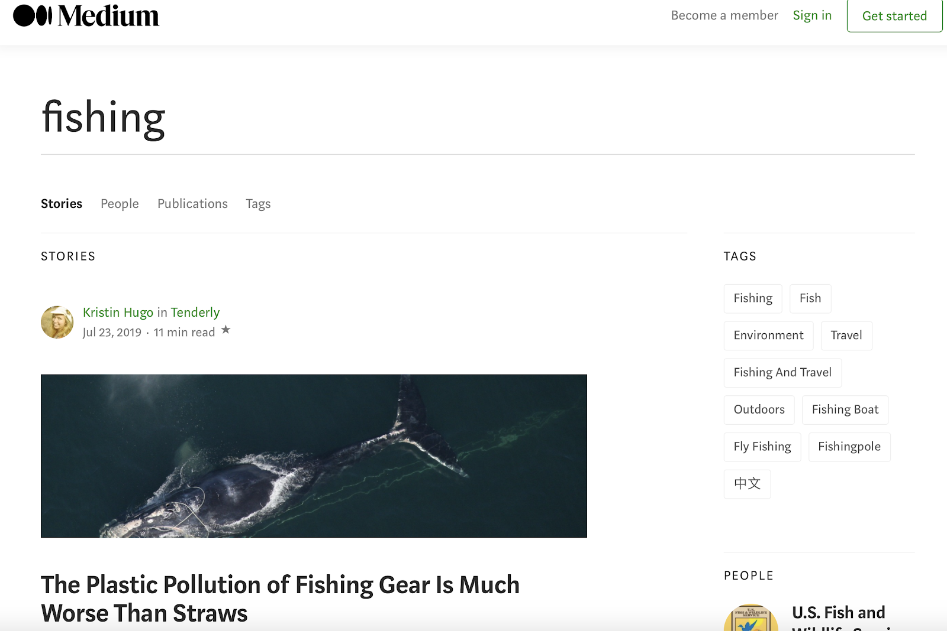

## **Searching on GitHub**

To search for case studies on GitHub, go to [github.com/search](https://github.com/search).

If you enter *fishing* in the search field, GitHub returns thousands of results. If you enter *fishing case study* in the search field, GitHub returns fewer results.

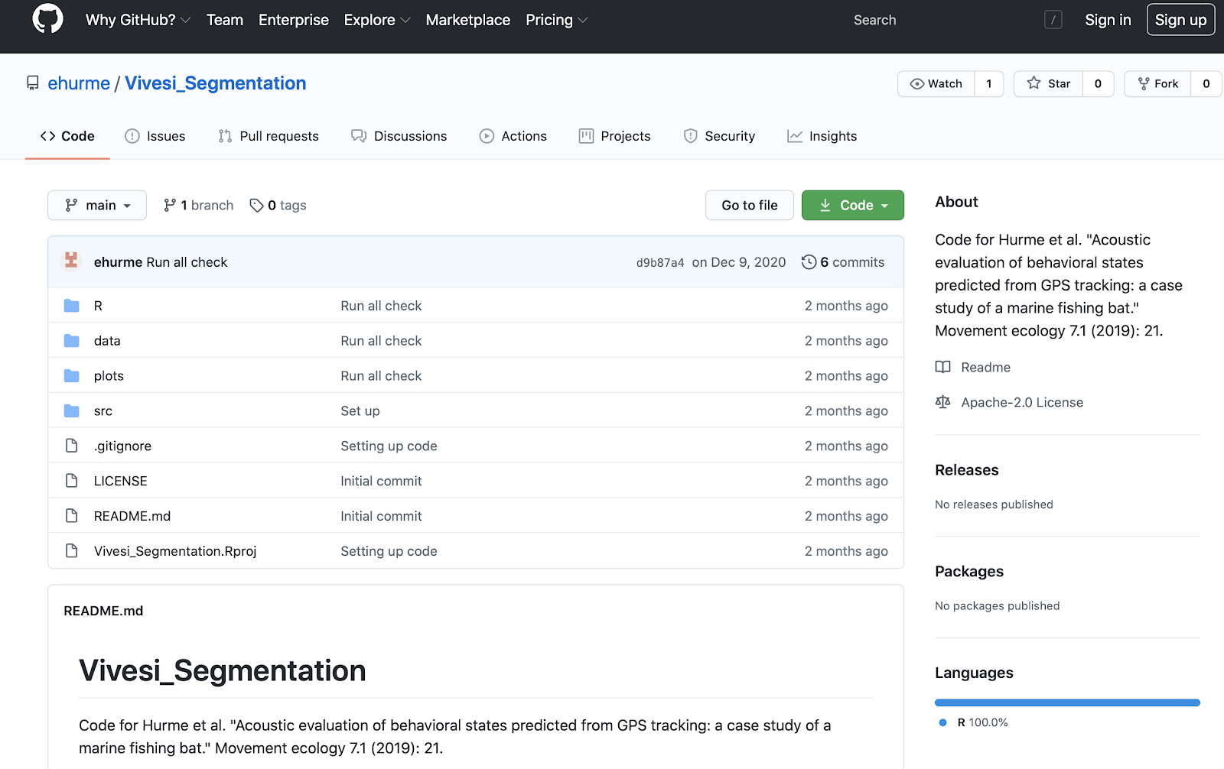

## **Searching on Tableau**

To search for case studies in Tableau, go to [public.tableau.com](http://public.tableau.com/) and use the search bar at the top of the page.

For example, click the search icon (the magnifying glass) and enter *fishing*. The term *fishing* returns thousands of results.

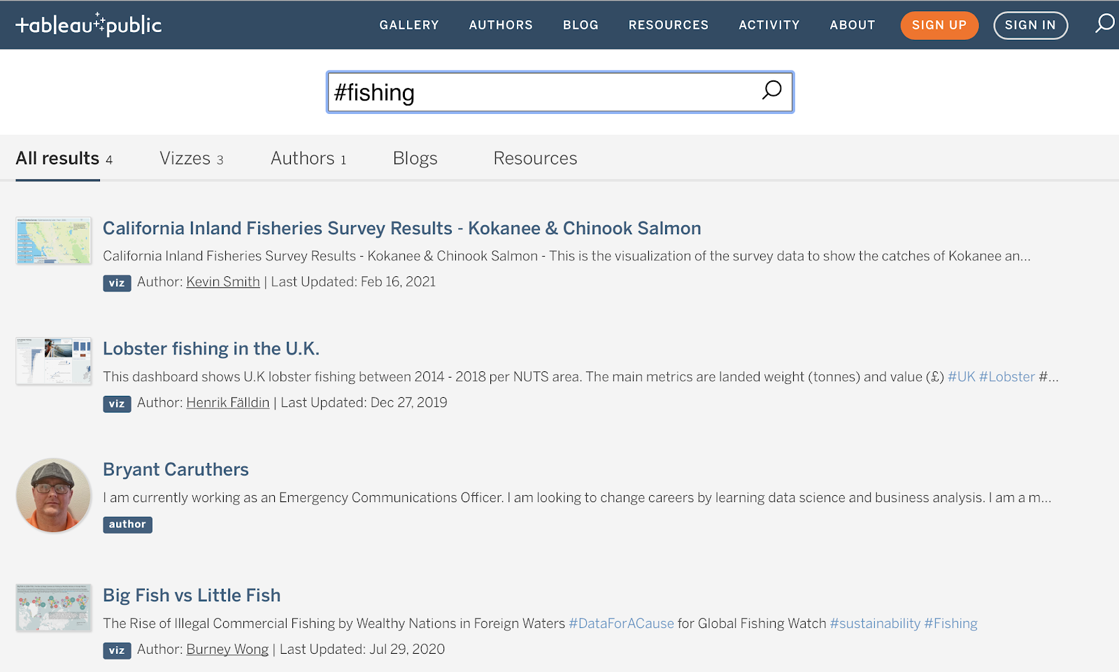

## **Searching on Kaggle**

To search for case studies on Kaggle, go to [kaggle.com](https://www.kaggle.com/) and use the search bar. For example, if you enter *fishing* in the search bar at the top of the page, you get results similar to the ones displayed below.

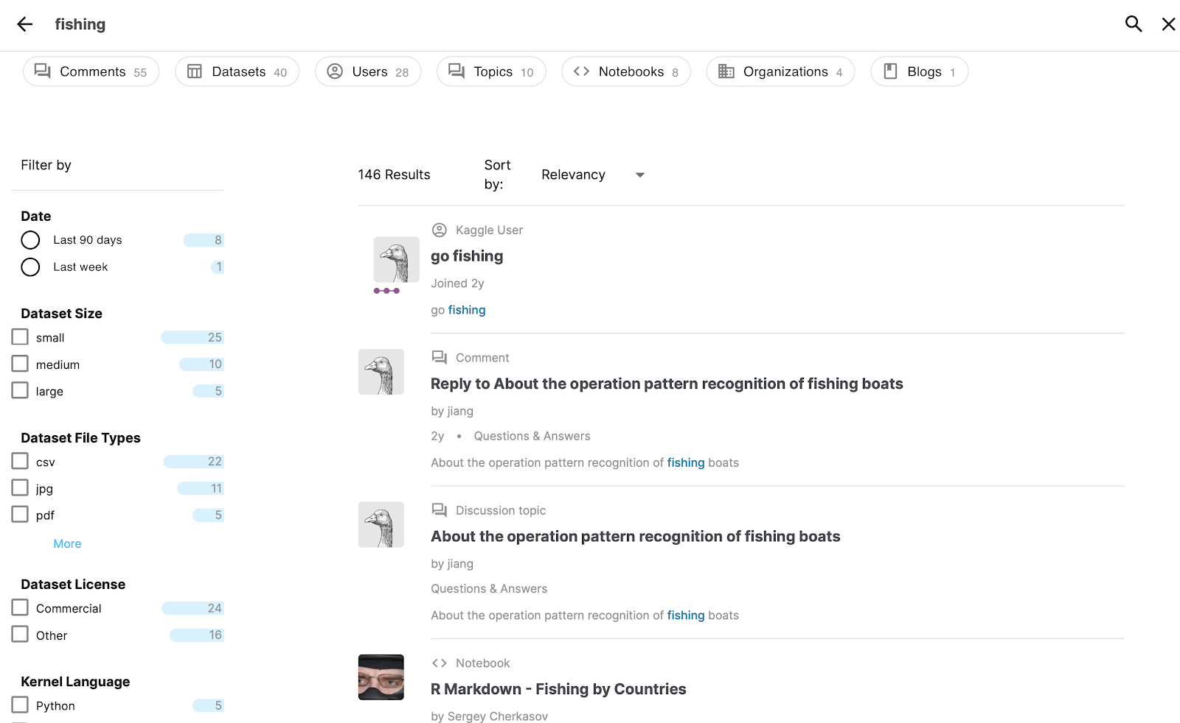

The *R Markdown - Fishing by Countries* notebook in Kaggle might be promising. You discover from this notebook that there is a public domain dataset called *Annual Nominal Fish Catches: Explore the impact of overfishing in the Northeast Atlantic region.*

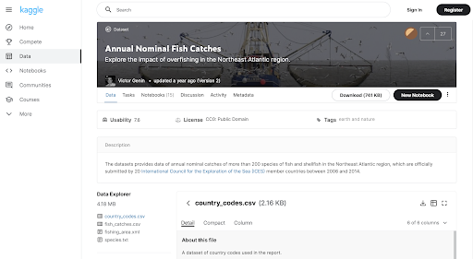

You might have just found a great dataset to use to create your own case study. You wouldn’t want to repeat the same analysis related to overfishing, but the data could reveal another pattern worth analyzing.

## 

## **Key takeaway**

You can use the same procedure completed for the fishing example to search for case studies and data about any other topic that interests you. By including case studies that are personally meaningful to you in your portfolio, you give prospective employers a better sense of the kind of person you are and what inspires your work.

[CASE STUDY 3: FOLLOW YOUR OWN CASE STUDY PATH](https://www.coursera.org/learn/google-data-analytics-capstone/discussionPrompt/2RsQw/case-study-3-follow-your-own-case-study-path)

SHARE YOUR CASE STUDY AND PORTFOLIO

[UNLIMITED POTENTIAL WITH ANALYTICS CASE STUDIES](https://www.coursera.org/learn/google-data-analytics-capstone/lecture/bQG93/unlimited-potential-with-analytics-case-studies)

[SHARE YOUR PORTFOLIO](https://www.coursera.org/learn/google-data-analytics-capstone/lecture/PaZYY/share-your-portfolio)

Hi there. Welcome back. Finishing the case study is a big step, but we still need to create a portfolio and share our analysis online. You have a lot of options when it comes to your own online portfolio. So, let's talk about where you can post your case study and how to make that decision. When you're thinking about where you want to share your portfolio, there's two questions that can help you decide. First, what platforms align with your interests and passions? And second, where do you want to spend more time after this program? You have a few options. You could use Kaggle, GitHub, a blog or Tableau to share your work. Now, let's talk about what each of these have to offer.

Kaggle has a broad data science community you could join. It hosts a lot of competitions for users to join in and offers all kinds of learning opportunities. This is a great option if you enjoy connecting with other data analysts.

GitHub's primarily used for programming languages like R or Python. It has a more technical setup than other platforms. But it's a great place to share your code and the how behind your analysis with other users. And if you want to learn from other data analysts' work, GitHub's a great place to be.

Blog platforms like Medium, WordPress and Google Sites are personalized and ownable.

Blogs aren't as code-focused as Kaggle and GitHub, so you'll have to store your code somewhere else. And there might be a few extra steps you'll have to take to display code on blogs. But you can show off your expertise, write about your process in your own voice, and show thought leadership in your field.

Finally, you might choose Tableau to host your work. You've already got some experience with Tableau from our work here. It's a great option if you're focused on the data viz side of things. Plus, you can create interactive dashboards using Tableau's tools that are easily shareable. Choosing where to host your portfolio is an important decision, but hopefully now you have some ideas about how each platform could be useful. And you might end up using multiple platforms over time to fit your specific needs.

The important thing is to remember the two questions we talked about earlier. **What platforms align with your interests and passions? And where do you want to spend more time after this program?**

Creating your online platform to share is one of the final steps in this capstone project. Coming up, we've got a few activities to help walk you through that process. Then we'll meet back here to start talking about your next steps.

[CREATE YOUR ONLINE PORTFOLIO](https://www.coursera.org/learn/google-data-analytics-capstone/supplement/m86c7/create-your-online-portfolio)

This reading provides a checklist about what to include in your portfolio, where you can set up accounts to host your portfolio, and how to add content to your portfolio.

## **What to include**

You learned that a portfolio represents your skills and showcases some of your previous projects to potential employers. Keep your portfolio:

* **Personal:** Show who you are, what you are interested in, and what is important to you.
* **Simple:** Display your work with easy navigation and without cluttered pages.
* **Relevant:** Match your work to the skills included in job descriptions.
* **Presentable:** Emphasize quality in the samples you show.
* **Unique:** Showcase your own work; cite sources of content to avoid plagiarism.

## **Where to set up accounts**

Choose a platform to host your portfolio. Medium, Google Sites, and Wordpress are good for blogging. GitHub and Kaggle are better for code. And finally, as you know, Tableau is great for visualizations. Next, create an account on the platform that you chose. Check out these steps to set up accounts on various platforms:

* [Set up an account on GitHub](https://docs.github.com/en/github/getting-started-with-github/signing-up-for-a-new-github-account)
* [Set up an account on Kaggle](https://www.kaggle.com/questions-and-answers/122858)
* [Set up an account on Tableau Public](https://public.tableau.com/s/) – *Click the orange "Sign Up" button*
* [Set up an account on Medium](https://help.medium.com/hc/en-us/articles/115004915268-Sign-in-or-sign-up-to-Medium)
* [Set up an account on WordPress](https://wordpress.com/start/user)
* [Set up a site on Google Sites](https://support.google.com/sites/answer/6372878?hl=en&ref_topic=7184580)

## 

## **How to add content to your portfolio**

Finally, refer to the following table for some links to articles that can help you to manage your portfolio. Articles are free but some sites limit the number of articles you can view per month. In that case, bookmark the article to view it later.

| **Platform** | **Information to help you manage your portfolio** |
| --- | --- |
| GitHub | [8 steps to publishing your portfolio on GitHub](https://medium.com/tunapanda-institute/8-steps-to-publish-your-portfolio-on-github-9d6e6e3d2e84): Follow the steps in this article to create a repository for your portfolio. |
| Kaggle | [Publishing your first dataset on Kaggle](https://medium.com/analytics-vidhya/publishing-your-first-dataset-on-kaggle-6be8c37e59e8): Follow the steps in this article to publish your own dataset and make it public. |
| Tableau | Any visualization created in Tableau Public is already public by default. A lot more is involved to add a Tableau visualization to another hosted site. For that reason, it is probably best to link to Tableau visualizations when your portfolio is hosted on a personal website or on a different platform, like GitHub. |
| Medium | [Getting started with a Medium publication](https://help.medium.com/hc/en-us/articles/115004681607-Getting-started-with-a-Medium-publication): Follow the process in this guide to create your own publication. |
| WordPress | [Get Published](https://wordpress.com/learn/get-published/): Follow these instructions to create pages or post content on your site. |
| Google Sites | [Publish & share your site](https://support.google.com/sites/answer/6372880): Follow these instructions to publish your site and share it publicly.  [Use a custom domain for your site](https://support.google.com/sites/answer/9068867): Refer to these instructions if you want to use a custom URL for your portfolio. |

[HANDS-ON ACTIVITY: ADD YOUR PORTFOLIO TO KAGGLE](https://www.coursera.org/learn/google-data-analytics-capstone/quiz/Ovp6u/hands-on-activity-add-your-portfolio-to-kaggle)

## **Activity Overview**



Earlier in this course, you learned about what to put in an effective data analyst portfolio. In this activity, you will add your portfolio content to a Kaggle notebook.

As you create your data analytics portfolio, you might find yourself using Kaggle or another online platform to host it. Kaggle hosts interactive notebooks that let you showcase your programming and hard work. If you have an existing portfolio, you can copy your content into Kaggle to have an additional way to share it.

By the time you complete this activity, you will have created a Kaggle notebook containing your portfolio content. Then you can easily share your work with a Kaggle link, enabling you to send your portfolio to more people.

### Step-By-Step Instructions

Follow the instructions to complete each step of the activity. Then answer the questions at the end of the activity before going to the next course item.

### Step 1: Review types of Kaggle Notebooks

First, it’s helpful to know the different kinds of Notebooks on Kaggle. Every kind of Kaggle Notebook uses code, but each one contains different languages for programming or writing text. The different types include:

* Scripts: Typically, these are code-only documents. Cells can be formatted in R or Python, and they execute each cell as code sequentially.
* RMarkdown scripts: Cells can be formatted in R and RMarkdown. These files are preferred by many R authors.
* Jupyter Notebooks: Cells can be formatted in Markdown, R, or Python. These are the most flexible.

Before you create a Notebook in Kaggle, decide which kind of Notebook you intend to use.

To share the code you wrote in this course, choose a Kaggle Notebook that supports R and Markdown, such as an R Markdown script or a Jupyter Notebook.

### Step 2: Add R to your Notebook

1. To begin, log in to Kaggle and go to [Kaggle.com/code](https://www.kaggle.com/code).

2. Select + Create and select < > New Notebook to create a new notebook. If you want to use an existing notebook, go to the Your work tab and scroll to the notebook you want to use.

3. Decide whether to use a type of script or a Jupyter notebook based on your project’s needs. The editor will begin as a notebook by default. If you want to change your notebook to a script, click on File at the top of your editor and hover over Editor Type. This opens a drop-down menu to select Notebook or Script. For this activity, select Notebook.

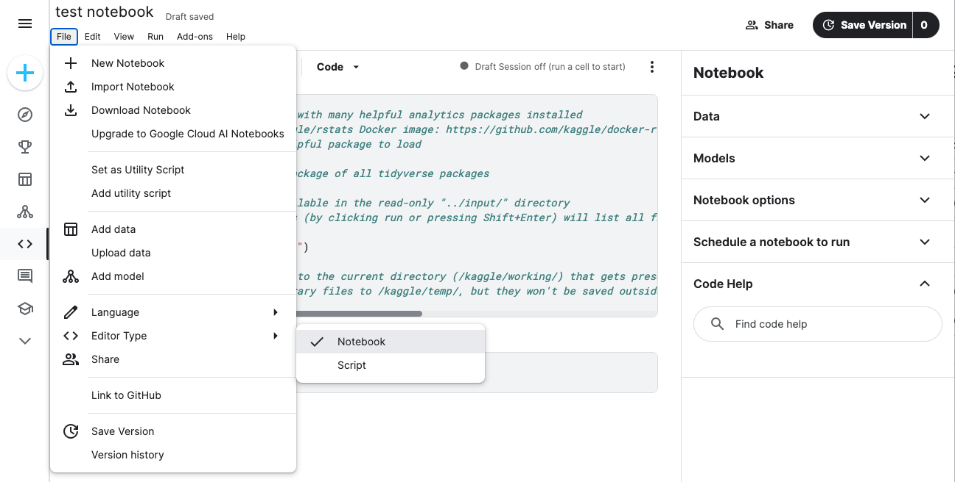

4. Because the work you did in the last course was in R instead of Python, you need to change the notebook’s language. Select File at the top of your editor and hover over Language. This opens a dropdown menu with both options available. Select R if it isn’t selected already.

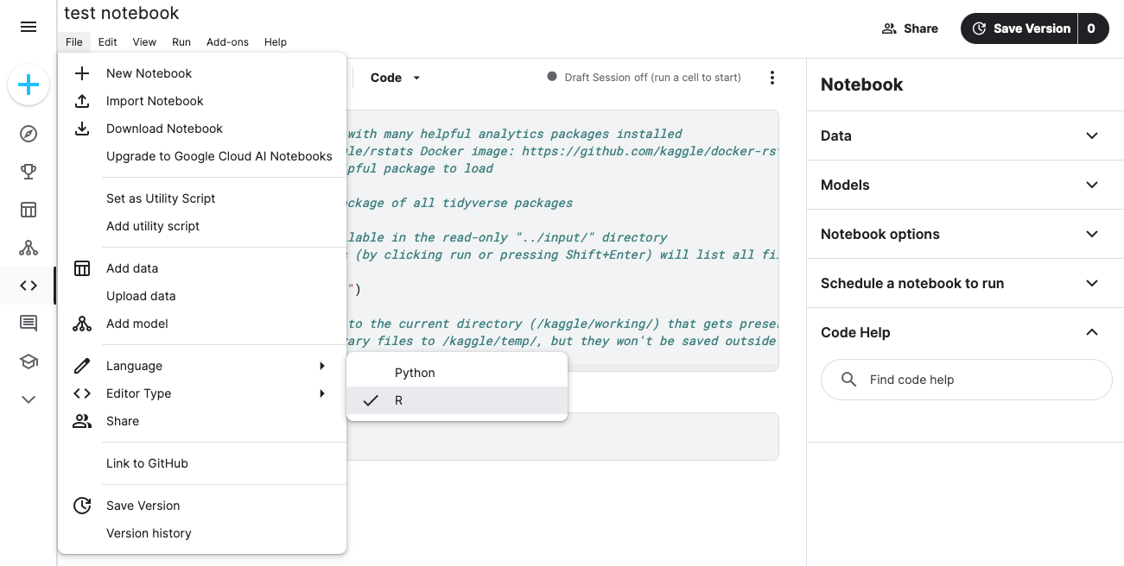

5. Open the file of a project you want to use in your portfolio. This can be the capstone project you completed during this course, an earlier activity you completed in a past course, or a personal project you created. Ideally, this project should demonstrate your coding ability and your data analytics knowledge.

6. Add the content of your portfolio piece. Copy the code you wrote into R cells and copy regular text or images into Markdown cells. To add a cell to the document, select + Code or + Markdown. It helps to test your code in the Kaggle interface by running it periodically as you write or copy it in. This way, you ensure that it doesn’t return an error.

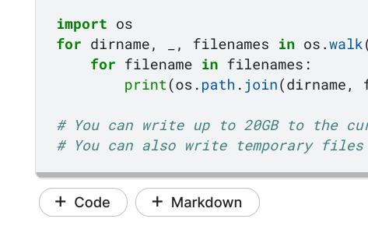

7. Repeat steps 2-6 to upload your portfolio pieces to their own Kaggle notebooks.

You have now created (or duplicated) your portfolio in Kaggle! Your next step is to publish your portfolio.

### Step 3: Publish your portfolio

Now it’s time to publicly publish your portfolio on Kaggle. This will allow peers, hiring managers, and potential employers to view your skill set and provide feedback.

* Note: When you publish your portfolio, you will also need to publicize all documents associated with it. For example, if you include a link to a document on Google Drive, you will need to ensure it is also publicly viewable.

1. To begin, navigate to the Your work tab on the Code screen to bring you to the list of your notebooks and scripts.

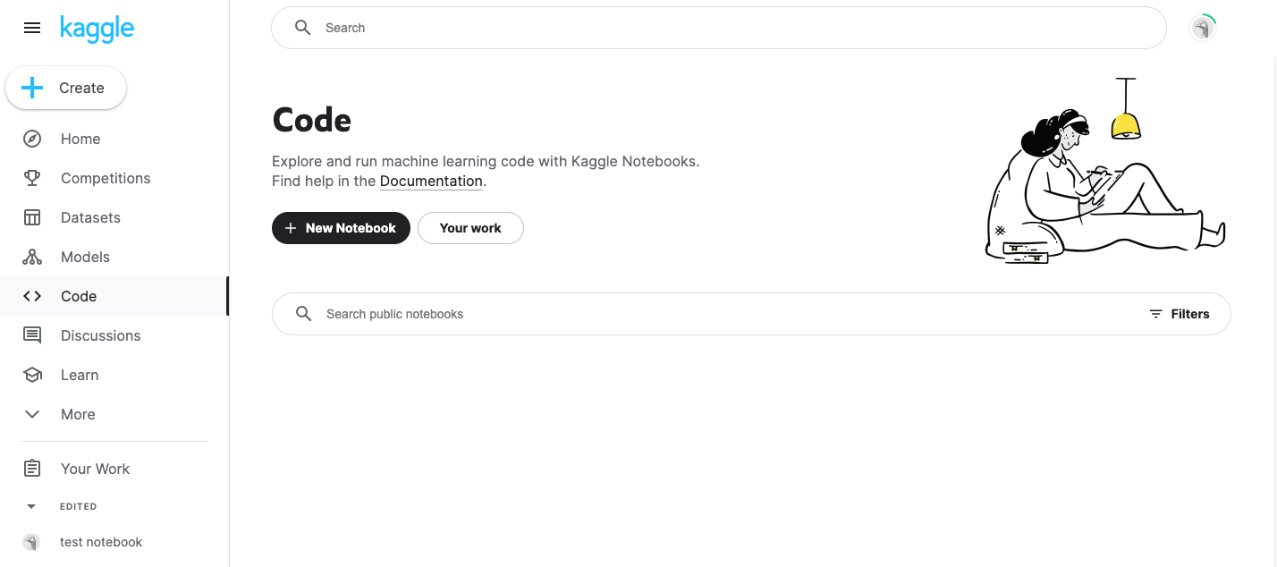

2. Select the first notebook or script you’d like to publicize. At the top right-hand corner, click the Share button.

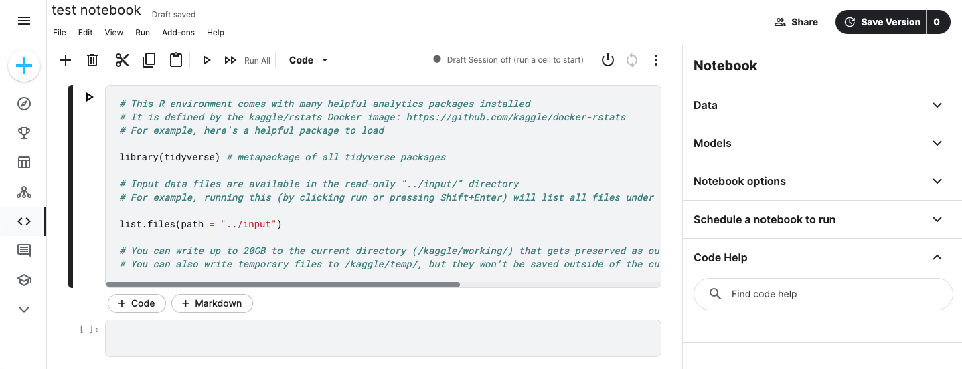

3. If the Share window indicates that the document is private, click the button next to the Public option.

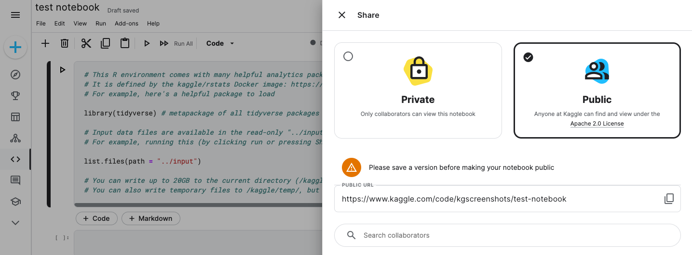

Once your project is public, you’ll be able to add relevant tags or any collaborators who contributed to the document. You can use tags to describe the topics your work relates to. [Click here](https://www.kaggle.com/tags) to learn more about which tags you can use on Kaggle.

4. Repeat these steps until you’ve made each piece in your portfolio public on Kaggle.

You have now uploaded your portfolio to Kaggle and can share your accomplishments with colleagues, hiring managers, and potential employers. You can update your portfolio as your skills as a data analyst continue to grow.

Now, share your portfolio by going to the Your work tab on Kaggle, selecting the project you’d like to share, and copying the URL from the address bar. Share this link to show the world your hard work!